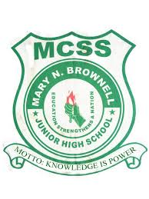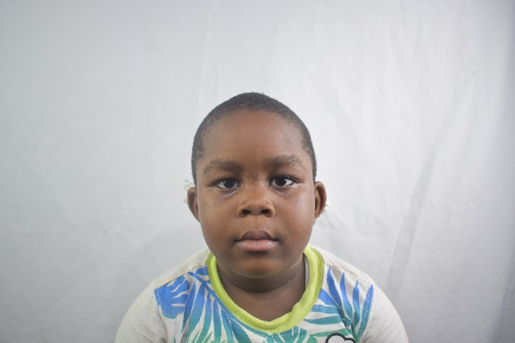

MARY N. BROWNELL JUNIOR HIGH SCHOOL

MCSS

12TH Street, Sinko

Monrovia, Liberia

M

N

B **Trokon Kwime**

J **2024-2025**

H T.Kwime

S Class: 7-1 AM